**26th February 2019**

**INTRODUCTION**

It has been a good experience in Akirachix in 2 weeks’ time. I have meet different ladies from diverse places. Different trainers who have passion in what that are doing. We learnt 8 units out of 10 where 2 are absent due to unavoidable situations. The units are:Lifeskills,Introduction to computer,hardware design,python,HTML CSS,Eterprenureship,Mobile development,Electronics,Javascript,Graphic design.

**Body**

**Life skills**

We learnt on how to be creative, time managers.

We watched Ted Talks of Chiamanda”Danger of a single story. “Which talked about racism, Self-confidence, how UK viewed Africa and aid it’s a country.

And many more Ted talks.

We come up with goals short term goals and long goals. We sticked the goals on a Manila paper so that we could see every day we walk up.

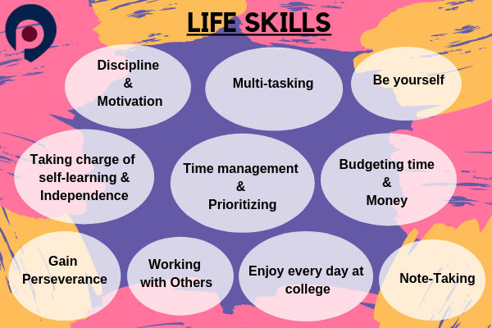

**Introduction to computer**

We learnt different parts of a computer the Hardware and Software Parts.

Software parts like Alice: Used to test things you design also called inventor.etc

Eg: Mouse, Monitor, Video graphics Adapter VGA/HDMI port, Thunder bold.

Functions of the parts: Eg fan Cools microprocessor.

Operating Systems: Window, Ubuntu.

Incognito browser-a browser which don’t save any of your file.

We learnt Typing skills.

How to use command prompt eg to create folder.

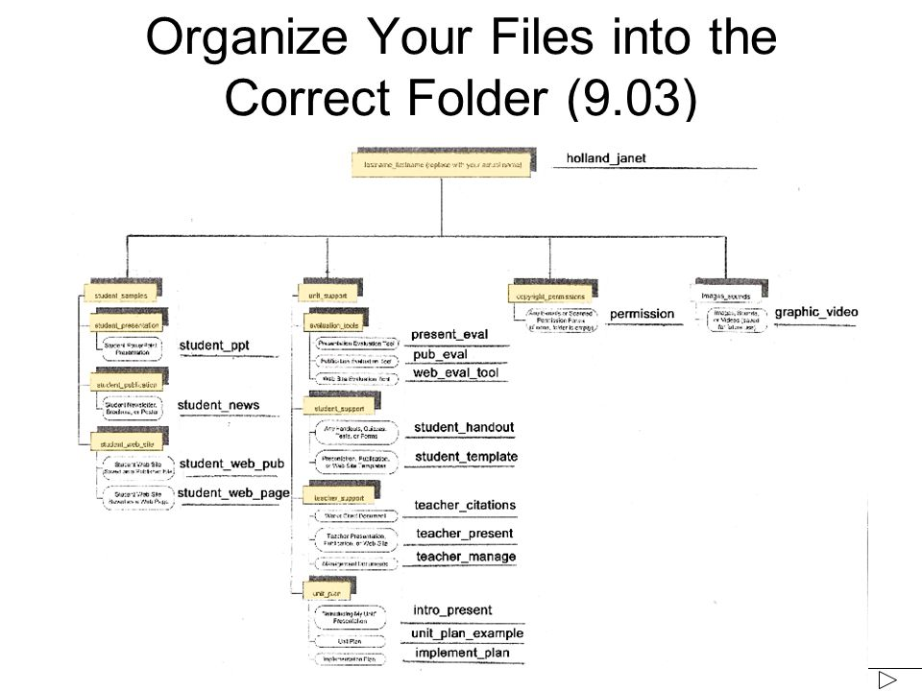

**Hardware design**

Introduction to product design

What is Printed Circuit Board.

What is a product

How to design a product using the seven stages

Design brief is necessary

1. Define Problem
2. Research
3. Ideation
4. Prototyping
5. Selections
6. Implementation
7. Learn

**Key principles of mind thinking**

Its Human centered

Collaborative teamwork

Learning by doing

Embracing experimentation

Understanding patterns Visualize

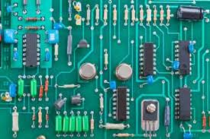

**Python**

What is python

How to install Python in a computer.

How to install a text editor.

Arithmetic in python

How to work with IDLE.



**HTML CSS**

Meaning of HTML-Hypertext mark-up language

CSS-Cascading Style sheets

How to create website. Writing codes.



**Entrepreneurship**

How to identify opportunities.

Mobile resources

Types of entrepreneurship

Qualities of entrepreneur:

Talent

Knowledge

Experience

Ways to innovate a business



**Electronics**

Comonents+Physics +Circuits (Basic Arithmetic, basic physics)

We learnt Matter, Atoms, Voltage, Current and Resistance.

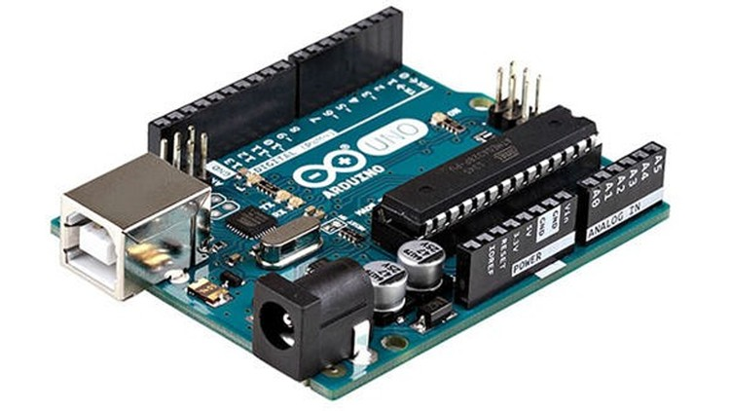

**Graphics Design**

In graphics you should be able to communicate using images.

We learnt if you want to be good in graphics:

Be Creative, Simple mind contrast be consistence in some of your drawings.

Using Adobe Illustrator.

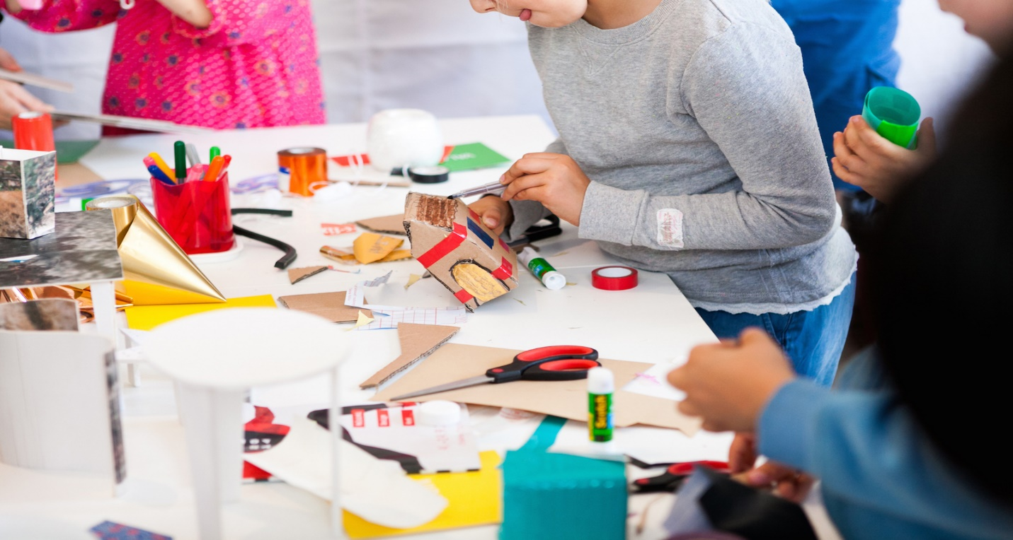

**Recommendations**

A mobile and Java script trainers should be found.